### Editing New Users

After adding a new user you will immediately be taken to the **Edit User** screen below. You will need to enter **User Group Settings**, and assign **Roles** and **Institutions**.

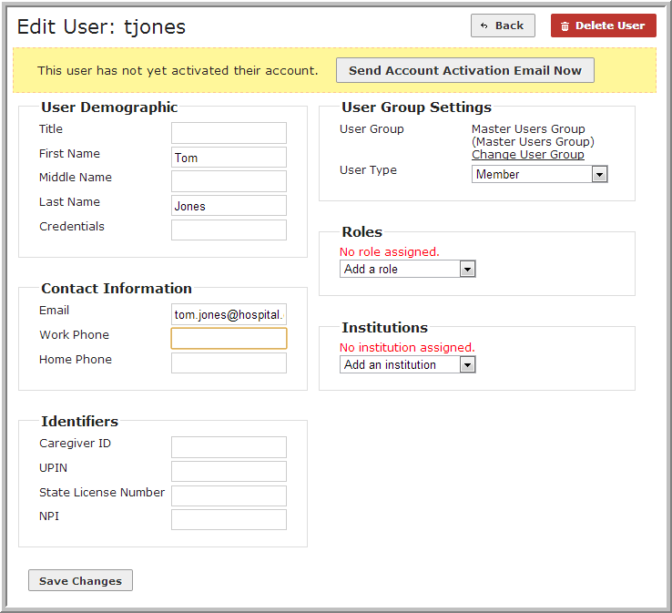

The **Send Account Activation Email Now** button at the top of the user account page allows the Administrator the option of immediately sending the account activation link or waiting until later (e.g., when creating multiple user accounts for a group go-live event).

If the account was created in error, click **Delete User** at any time during the process. The username will be made immediately available for use again in the system.